Academic Program Review
Self-Study

[Program Name]
[Department of Division Name]
[College Name]

Review period: [Year-Year]
Submitted: [Month Year]

Table of Contents
Introduction 4
Background and Purpose of the Self-Study 4
Scope of the Self-Study 4
1. Overview of the Program 6
A. Mission 6
B. Response to Results of Previous Evaluation 6
C. Program Accreditation 6
2. Relevance of the Program 7
A. Completer Indicators of Relevance 7
B. Occupational Indicators of Relevance 7
C. Other Indicators of Relevance 8
D. Limitations 8
E. Conclusion 8
3. Design of the Program 9
A. Curriculum 9
B. Student Learning Goals and Outcomes 9
C. Modes of Delivery 10
D. Other Attributes of Design 10
E. Limitations 10
F. Conclusion 10
4. Implementation of the Program 11
A. Student Enrollment 11
B. Student Completion 11
C. Faculty Workload 12
D. Faculty Scholarship 12
E. Partnerships 12
F. Other Indicators of Implementation 13
G. Limitations 13
H. Conclusion 13
5. Impact of the Program 14
A. Student Learning Outcome Assessment 14
B. Operational Assessment 14
C. Other Results 14
D. Limitations 15
E. Conclusions 15
6. Resources for the Program 16
A. Faculty 16
B. Support Services 16
C. Technology 16
D. Other Resources 17
D. Limitations 17
E. Conclusions 17
7. SWOT 18
A. Strengths 18
B. Weaknesses 18
C. Opportunities 18
D. Threats 18
8. Plans 19
A. Goals 19
B. Strategies 19
C. Actions 19
D. Logic Model (optional) 20
References 22

Introduction
This section describes the background, purpose, and scope of this self-study.
Background and Purpose of the Self-Study
North Dakota State Board of Higher Education ([SBHE], 2005) policy 403.1.2 Institutional Instructional Program Evaluation requires undergraduate programs to be comprehensively evaluated at a minimum of every seven years and graduate programs to be comprehensively evaluated at a minimum of every ten years. The evaluation must include a comprehensive self-study that addresses “assessments of the current level of program quality, relationship of the program to the mission of the institution, and program productivity” (para. 1). The general purpose of a comprehensive program evaluation is to systematically collect and analyze a range or information pertinent to the quality of the program to draw conclusions and make decisions related to its existence and implementation (Rossi et al., 2004; Stufflebeam & Coryn, 2014; Yarbrough et al., 2011). Thus, the purpose of this Program Review Self-Study is to comprehensively evaluate the program to:
- Meet the requirement for a comprehensive self-study outlined in SBHE (2005) policy 403.1.2
- Provide the program, institution, and university system with information about the program to inform decisions related to its existence and implementation.

Scope of the Self-Study
This self-study includes an overview of the program, discussions of program quality based on five categories of assessment that are worthwhile to consider when conducting a comprehensive evaluation of a program (Anderson, 2022; Rossi et al., 2004), limitations of the results, conclusions, and plans for next steps. The five categories of assessment that address program quality are as follows:
- Needs assessment: This category addresses why there is a need for the program.
- Theory assessment: This category addresses how the program's design is appropriate to meet the identified needs.
- Process assessment: This category addresses how well the program is being implemented according to its design.
- Outcome assessment: This category addresses how well the program is achieving its desired results.
- Efficiency assessment: This category addresses whether resources are being efficiently utilized to implement the program.
If a needs assessment indicates that there is a need for the program, and if a theory assessment indicates that the design of the program is appropriate to meet the need, and if a process assessment indicates that the program is being implemented appropriately, and if an outcome assessment indicates that the program is achieving its desired results, and if an efficiency assessment indicates that the program is using its resources efficiently, then the program is likely to be considered a quality program.

This self-study includes eight sections: 1. Overview of the program; 2. Relevance of the program; 3. Design of the program; 4. Implementation of the program; 5. Impact of the program; 6. Resources for the program; 7. SWOT; and 8. Plan. Sections 2-6 align with the five categories of assessment. Section 7 is a SWOT analysis summarizing strengths, weaknesses, opportunities, and threats (Helms & Nixon, 2010) based on responses provided in the sections related to the five assessment categories. Section 8 is a plan based on the responses provided in the SWOT and assessment-related sections. Figure 1 depicts how the sections address program quality through their alignment with the five categories of assessment that support a comprehensive evaluation of a program.

Figure 1
Self-Study Alignment with 5 Categories of Assessment
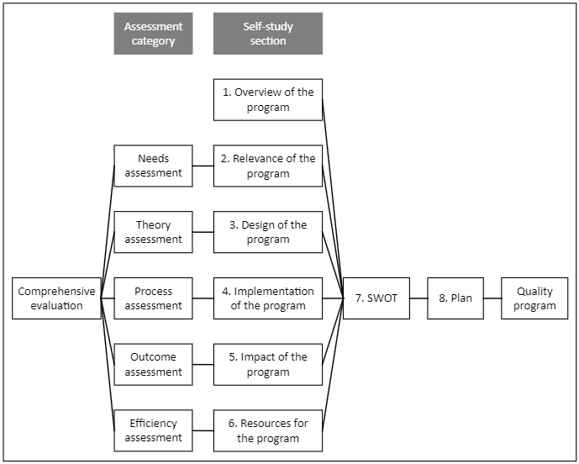

1. Overview of the Program
This section provides an overview of the program in terms of its mission and a summary of its response to the results of its previous evaluation.

A. Mission
1. Describe the mission of the program. Include the program’s primary purpose, functions, and stakeholders served.

2. Describe any changes that were made to the mission since the last program review and why they were made.

3. Explain how the mission of the program relates to the mission of the institution.

B. Response to Results of Previous Evaluation
1. Summarize the concerns from the previous program review.

2. Summarize the goals and action items from the previous program review.

3. Describe the extent to which progress was made toward achievement of the goals and implementation of the action items from the previous program review.

C. Program Accreditation
1. If applicable, provide the name of the accrediting agency, accreditation status, date of the most recent accreditation decision, and date of the next accreditation.

2. Relevance of the Program
This section aligns with the needs assessment category of assessment, which addresses why there is a need for the program. The relevance of the program is addressed through completer, occupational, and other indicators.

A. Completer Indicators of Relevance
1. Describe evidence of the relevance of the program based on quantitative and/or qualitative completer indicators. The following metrics and/or other relevant indicators may be helpful in demonstrating the extent to which there is a need for the program:
- # regional completions by year (Data source: Lightcast, Program Overview)
- # change in 10-year regional annual completions (Data source: Lightcast, Program Overview)
- % change in 10-year regional annual completions (Data source: Lightcast, Program Overview)]
- Other quantitative and/or qualitative completer indicator(s):_____

B. Occupational Indicators of Relevance
1. List target occupations related to the program. (Data Source: Lightcast, Program Overview)

2. Describe evidence of the relevance of the program based on quantitative and/or qualitative occupational indicators. The following metrics and/or other relevant indicators may be helpful in demonstrating the extent to which the program is relevant:
- # unique job postings (Data Source: Lightcast, Program Overview)
- #:# posting intensity (Data Source: Lightcast, Program Overview)
- # days median job posting duration (Data Source: Lightcast, Program Overview)
- # projected change in jobs over the next 5 years in region (Data Source: Lightcast, Program Development and Review)
- % projected change in jobs over the next 5 years in region (Data Source: Lightcast, Program Development and Review)
- # projected change in jobs over the next 5 years in nation (Data Source: Lightcast, Program Development and Review)
- % projected change in jobs over the next 5 years in nation(Data Source: Lightcast, Program Development and Review)
- Other quantitative and/or qualitative occupational indicator(s):_____

C. Other Indicators of Relevance
1. Describe evidence of the relevance of the program based on other quantitative and/or qualitative indicators.

D. Limitations
1. Describe limitations of the responses in this section related to the relevance of the program.

E. Conclusion
1. Summarize why the program is relevant based on the responses in this section.

3. Design of the Program
This section aligns with the theory assessment category of assessment, which addresses how the program’s design is appropriate to meet the identified needs. The program’s design is discussed in terms of its curriculum, student learning goals and outcomes, and modes of delivery.

A. Curriculum
1. Describe the course pathways that students follow to complete the degree.

2. Describe any changes that have been made to the course pathways since the previous program review and why the changes were made.

3. Identify the number of catalog courses for the program

4. Identify the program’s courses that are also recognized as general education courses.

5. Identify the courses in the program that are required by other majors/minor.

6. Describe courses that may be appropriate to add to, remove from, or modify within the curriculum.

B. Student Learning Goals and Outcomes
1. List the Student Learning Goals (SLGs) and Student Learning Outcomes (SLOs) of the program. Identify where the SLGs and SLOs are covered in the curriculum.

2. Describe any changes that were made to the SLGs and/or SLOs since the last program review and why there made.

3. Describe how the SLGs and SLOs relate to the program’s mission.

4. Describe potential changes to the SLGs and SLOs that may be worth consideration and why any changes may be important to make.

C. Modes of Delivery
1. Describe the program modes of delivery that are available to students (e.g., face-to-face, online, hybrid).

2. Explain how the current modes of delivery meet market demand.

3. Describe potential changes to modes of delivery that may be appropriate to consider and why any changes may be worth making.

D. Other Attributes of Design
1. If applicable, describe other key indicators of the program’s design.

E. Limitations
1. Describe limitations of the responses in this section related to the program’s design.

F. Conclusion
1. Summarize how the design of the program is appropriate to meet the need.

2. Summarize areas where the design of the program may need to be improved.

4. Implementation of the Program
This section aligns with the process assessment category of assessment, which addresses how well the program is being implemented according to its design. The program’s implementation is discussed in terms of student enrollment, student completion, faculty workload, faculty scholarship, and partnerships.

A. Student Enrollment
1. Describe evidence of program implementation based on quantitative and/or qualitative enrollment indicators. The following metrics and/or other relevant indicators may be helpful in demonstrating the extent to which the program is being implemented as intended:
- # major enrollments by year (Data source: MSU IR Office)
- # minor enrollments by year (Data source: MSU IR Office)
- % change in 5-year major enrollments (Data source: MSU IR Office)
- % change in 5-year minor enrollments (Data source: MSU IR Office)
- # change in 3-year course enrollments (Data source: MSU IR Office)
- % change in 3-year course enrollments (Data source: MSU IR Office)
- # total credit hours (Data source: MSU IR Office)
- Other quantitative and/or qualitative enrollment indicator(s):_____
Disaggregate the data by mode of delivery, demographic characteristics, and other indicators as appropriate.

2. Describe the extent to which the program is meeting its expectations for enrollment.

3. Describe potential strategies for sustaining or improving enrollment.

B. Student Completion
1. Describe evidence of program implementation based on completion indicators. The following metrics and/or other relevant completion indicators may be helpful in demonstrating the extent to which the program is being implemented as intended:
- Total number of degrees awarded by year (Data source: MSU IR Office)
- % change in number of degrees awarded between 5 years (Data source: MSU IR Office)
- Other quantitative and/or qualitative student completion indicator(s):_____
Disaggregate the data by mode of delivery, demographic characteristics, and other indicators as appropriate.

2. Describe the extent to which the program is meeting its expectations for completions.

3. Describe potential strategies for sustaining or improving program completion.

C. Faculty Workload
1. Describe evidence of program implementation based on faculty workload indicators. The following metrics and/or other relevant indicators related to faculty workload may be helpful in demonstrating the extent to which the program is being implemented as intended:
- # credit hours per FTE faculty (Data source: MSU IR Office)
- # average class size (Data source: MSU IR Office)
- Student to faculty ratio (Data source: MSU IR Office)
- # average advisees per faculty FTE (Data source: MSU IR Office)
- Other quantitative and/or qualitative faculty workload indicators:_____
2. Describe the extent to which the program is meeting its expectations for faculty workload.

3. Describe potential strategies for sustaining or improving faculty workload.

D. Faculty Scholarship
1. Summarize the scholarly productivity of program faculty members.

2. Describe the extent to which the expectations for scholarly productivity are being met.

3. Describe potential strategies for sustaining or improving scholarly productivity.

E. Partnerships
1. Describe how the program collaborates with different academic programs or other internal entities on campus to promote student learning.

2. Describe how the program is collaborating with outside organizations or other external entities off campus to promote student learning.

3. Describe the extent to which the expectations for internal and external partnerships are being met.

4. Describe potential strategies for sustaining or improving internal and external partnerships.

F. Other Indicators of Implementation
1. If applicable, describe the results of other key indicators related to program implementation.

G. Limitations
1. Describe limitations of the responses in this section related to the implementation of the program.

H. Conclusion
1. Summarize the extent to which the program is being implemented appropriately.

2. Summarize areas where the implementation of the program may need to be improved.

5. Impact of the Program
This section aligns with the outcome assessment category of assessment, which addresses how well the program is achieving its desired results. The impact of the program is discussed in terms of student learning outcomes assessment, operational assessment, and other results.

A. Student Learning Outcome Assessment
1. Describe the program’s Student Learning Outcome assessment plan.

2. Summarize the program’s Yearly Program Assessment (YPA) findings related to SLOs. Include strengths and weaknesses using comparative data.

3. Describe changes made to the program in response to its YPA SLO findings.

B. Operational Assessment
1. Describe the program’s Operational Outcome (OO) assessment plan.

2. Summarize the program’s YPA findings related to OOs. Include strengths and weaknesses using comparative data.

3. Describe changes made to the program in response to its YPA OO findings.

C. Other Results
1. Describe any other assessment or evaluation plans implemented by the program beyond the scope of its SLOs and OOs.

2. Summarize the program’s findings related to assessments beyond the scope of its SLOs and OOs. Include strengths and weaknesses using comparative data.

3. Describe changes made to the program in response to its assessment findings beyond the scope of its SLOs and OOs.

D. Limitations
1. Describe limitations of the responses in this section related to the program's impact and other applicable results.

E. Conclusions
1. Summarize the extent to which the program is achieving its desired results.

2. Summarize areas where outcomes may need to be improved.

6. Resources for the Program
This section aligns with the efficiency assessment category of assessment, which addresses whether resources are being efficiently utilized to implement the program. The resources for the program are discussed in terms of faculty, support services, technology, and other resources.

A. Faculty
1. Describe the processes in place to ensure that faculty are qualified to teach in the program.

2. Describe the qualifications of the faculty

3. Describe the teaching status of the faculty. The following indicators may be helpful in demonstrating the teaching status of the faculty:
- Total number of FTE faculty (Data source: MSU HR Office)
- % full-time faculty (Data source: MSU HR Office)
- % part-time faculty (Data source: MSU HR Office)
- Other: ___

4. Describe the extent to which the expectations for the qualifications and teaching status of the faculty are being met.

5. Describe strategies for sustaining or improving the qualifications and/or teaching status of the faculty.

B. Support Services
1. Describe how the program utilizes support services such as the library, student services, academic support services, Foundation, IT Central, Registrar, and other support offices.

2. Identify any additional needs for support that are necessary for effective program delivery.

C. Technology
1. Describe how technology is integrated into the program.

2. Describe technologies that may be appropriate to add, discontinue, or otherwise modify.

D. Other Resources
1. Describe how the program utilizes other key resources.

2. Describe other key resources that may be appropriate to add, discontinue, or otherwise modify.

D. Limitations
1. Describe limitations of the responses in this section related to the resources for the program.

E. Conclusions
1. Summarize the extent to which the program is using its resources efficiently.

2. Summarize areas where the utilization or availability of resources may need to be improved.

7. SWOT
This section summarizes the program’s strengths, weaknesses, opportunities, and threats based on the information presented in the previous sections of this self-study.

A. Strengths
1. Summarize the internal positive attributes of the program. For example:
- What does the program do well?
- What are the program’s advantages?
- What do others see as the program’s strengths?
- What could the program boast about its operation?

B. Weaknesses
1. Summarize internal negative attributes about the program. For example:
- What can be improved?
- What should be avoided?
- What could be done more effectively and efficiently in the program?
- What is the program not doing that it should be doing?

C. Opportunities
1. Summarize external conditions that could have a positive effect on achievement. For example:
- What are the opportunities facing the program?
- What are some current trends that could have a positive impact on the program?

D. Threats
1. Summarize external conditions that could have a negative impact on achievement?
- What obstacles does the program face?
- How are changing resources, technology, or external requirements affecting the program’s ability to provide services?
- What are some current trends that could have a negative impact on the program?

8. Plans
This section outlines plans for next steps based on the information presented in the previous sections of this self-study.

A. Goals
1. Establish goals based on the information in the Need, Design, Implementation, Results, and Resources sections.

B. Strategies
1. Identify one or more strategies that could support the achievement of each goal.

C. Actions
1. Write an action plan to guide the implementation of each strategy.

The following template may be helpful in outlining your goals, strategies, and action plan.
Goal | Strategy | Action | Who | When
1 | 1.1 | 1.1.1
 |  | 1.1.2
 |  | 1.1.n
 | 1.2 | 1.2.1
 |  | 1.2.2
 |  | 1.2.n
2 | 2.1 | 2.1.1
 |  | 2.1.2
 |  | 2.1.n

D. Logic Model (optional)
1. Develop a logic model to demonstrate that your action plan is related to a need, outline the outputs and outcomes that are expected to result from its implementation, and identify resources that are required for it to be implemented. For example:
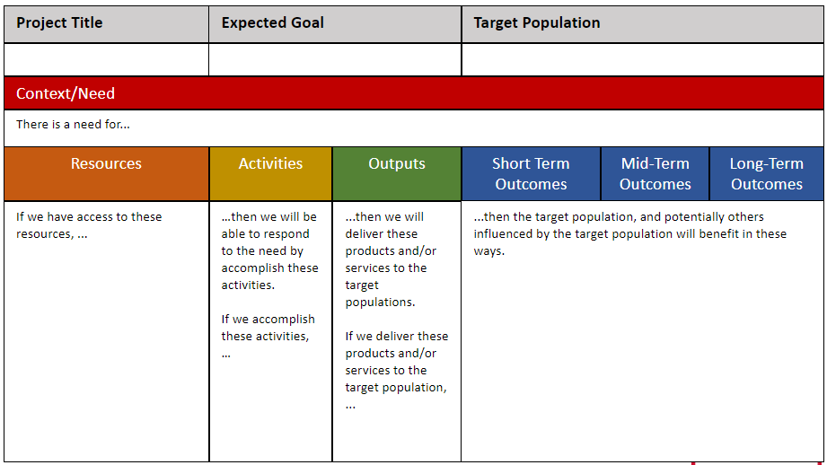

Logic Model Template
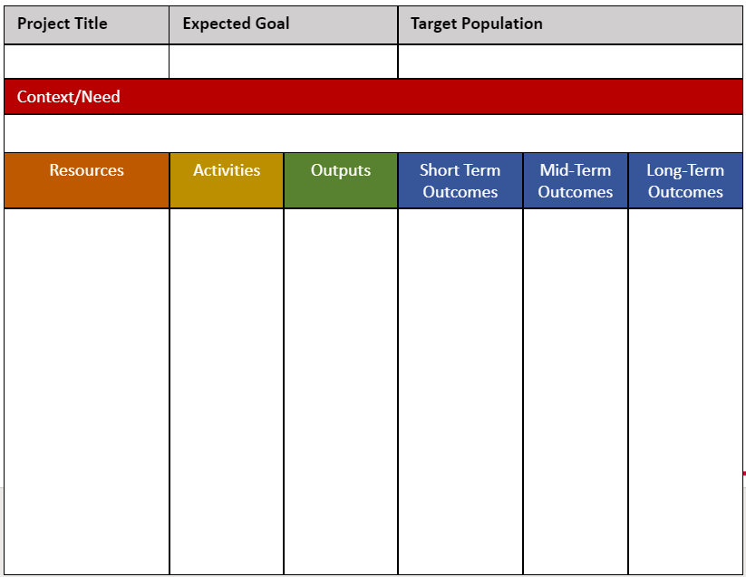

References
Anderson, N. (2022). Synthesizing frameworks and tools to develop a plan for evaluating an online data utilization curriculum for teachers. Evaluation and Program Planning, 94. https://doi.org/10.1016/j.evalprogplan.2022.102148
Helms, M. M., & Nixon, J. (2010, August 10). Exploring SWOT analysis – where are we now? A review of academic research from the last decade. Journal of Strategy Management, 3(3), 215-251.
North Dakota State Board of Higher Education. (2005, September 15). Policy 403.1.2 Institutional instructional program evaluation. https://ndus.edu/sbhe-overview/sbhe-policies/
Rossi, P. H., Lipsey, M. W., & Freeman, H. E. (2004). Evaluation: A systematic approach (2nd ed.). Sage.
Stufflebeam, D. L., & Coryn, C. L. (2014). Evaluation theory, models and applications (2nd ed.). Jossey-Bass.
Yarbrough, D. B., Shulha, L. M., Hopson, R. K., & Carutheres, F. A. (2011). The program evaluation standards: A guide for evaluators and evaluation users (3rd ed.). Sage.

